ALUNOS: João Felipe e Martha Monteiro
1)
#!/usr/bin/python

'Setting the position of nodes'

from mininet.node import Controller
from mininet.log import setLogLevel, info
from mininet.wifi.cli import CLI_wifi
from mininet.wifi.node import OVSKernelAP
from mininet.wifi.net import Mininet_wifi

def topology():

net = Mininet_wifi(controller=Controller, accessPoint=OVSKernelAP)

info("*** Creating nodes\n")
sta1 = net.addStation('sta1', mac='00:00:00:00:00:02', ip='10.0.0.1/8',
position='30,60,1')
sta2 = net.addStation('sta2', mac='00:00:00:00:00:03', ip='10.0.0.2/8',
position='70,30,2')
sta3 = net.addStation('sta3', mac='00:00:00:00:00:02', ip='10.0.0.3/8',
position='50,60,3')
sta4 = net.addStation('sta4', mac='00:00:00:00:00:03', ip='10.0.0.4/8',
position='20,30,4')

ap1 = net.addAccessPoint('ap1', ssid='acp1', mode='g', channel='1',
position='50,50,0')
ap2 = net.addAccessPoint('ap2', ssid='acp2', mode='g', channel='2',
position='50,50,0')
c1 = net.addController('c1', controller=Controller)

h1 = net.addHost('h1', ip='10.0.0.3/8')
h2 = net.addHost('h2', ip='10.0.0.2/8')

net.propagationModel(model="logDistance", exp=4.5)
h1.plot('10,10,10')
h2.plot('30,20,50')

info("*** Configuring wifi nodes\n")
net.configureWifiNodes()

info("*** Creating links\n")
net.addLink(ap1, h1)

net.plotGraph(max_x=100, max_y=100, max_z=100)

info("*** Starting network\n")
net.build()
c1.start()
ap1.start([c1])

info("*** Running CLI\n")
CLI_wifi(net)

info("*** Stopping network\n")
net.stop()

if __name__ == '__main__':
setLogLevel('info')
topology()

b)

net.addLink( sta1, ap1 )
net.addLink( sta1, ap1 )
net.addLink( sta3, ap2 )
net.addLink( sta4, ap2 )

c) O arquivo.py completo foi executado : “ sudo python arquivo.py”
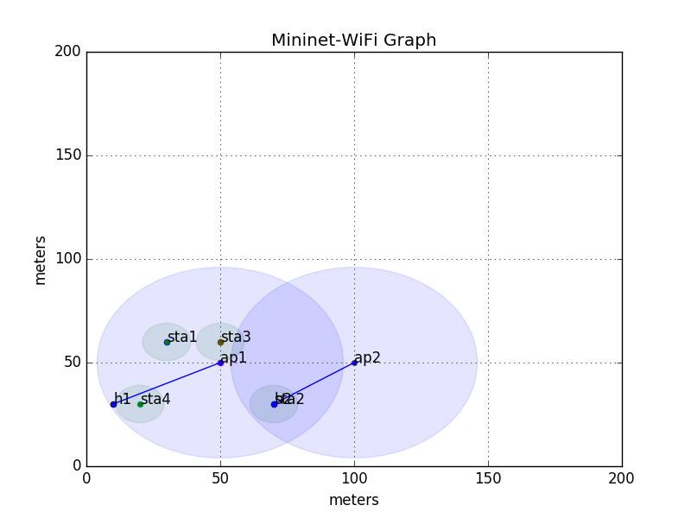

d) O código “net.addLink(x, y)” foi utilizado para conectar os hosts ao ponto de acesso.

net.addLink(ap1, h1)
net.addLink(ap2, h2)

e) Os pontos de acesso estão conectados em um mesmo controlador devido a este código :

c1.start()
ap1.start([c1])
ap2.start([c1])

2.
Utilizando o código “sta1 ping sta2” percebe-se que há conexão entre as estações :

mininet-wifi> sta1 ping sta2
PING 10.0.0.2 (10.0.0.2) 56(84) bytes of data.
64 bytes from 10.0.0.2: icmp_seq=1 ttl=64 time=3.04 ms
64 bytes from 10.0.0.2: icmp_seq=2 ttl=64 time=2.90 ms
64 bytes from 10.0.0.2: icmp_seq=3 ttl=64 time=2.90 ms
64 bytes from 10.0.0.2: icmp_seq=4 ttl=64 time=2.89 ms
^C
--- 10.0.0.2 ping statistics ---
4 packets transmitted, 4 received, 0% packet loss, time 3005ms
rtt min/avg/max/mdev = 2.897/2.937/3.041/0.060 ms

Utilizando o código “h1 ping h2” percebe-se que há conexão entre os hosts :

mininet-wifi> h1 ping h2
PING 10.0.0.2 (10.0.0.2) 56(84) bytes of data.
64 bytes from 10.0.0.2: icmp_seq=1 ttl=64 time=4.21 ms
64 bytes from 10.0.0.2: icmp_seq=2 ttl=64 time=1.98 ms
64 bytes from 10.0.0.2: icmp_seq=3 ttl=64 time=1.66 ms
^C
--- 10.0.0.2 ping statistics ---
3 packets transmitted, 3 received, 0% packet loss, time 2002ms
rtt min/avg/max/mdev = 1.666/2.621/4.216/1.135 ms

3. As estações e pontos de acesso foram conectadas usando estas linhas de comando:

info("*** Creating links\n")
net.addLink(ap1, h1)
net.addLink(ap2, h2)
net.addLink(ap1, ap2, cls=_4address)
net.addLink( sta1, ap1 )
net.addLink( sta1, ap1 )
net.addLink( sta3, ap2 )
net.addLink( sta4, ap2 )

Modificamos a posição do ap2 para (‘80,50,0’) e conseguimos conectar h1 com h2:
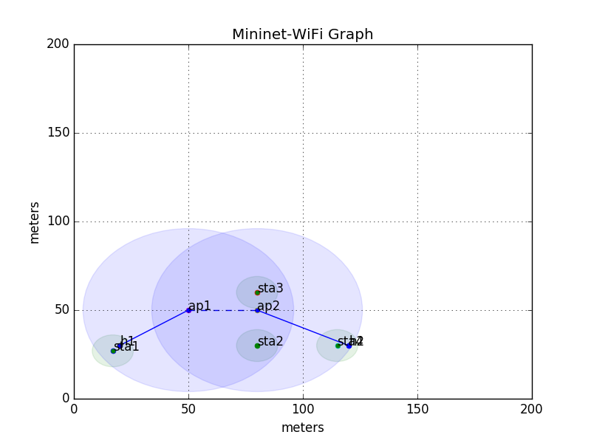

mininet-wifi> h1 ping h2
PING 10.0.0.2 (10.0.0.2) 56(84) bytes of data.
64 bytes from 10.0.0.2: icmp_seq=1 ttl=64 time=12.5 ms
64 bytes from 10.0.0.2: icmp_seq=2 ttl=64 time=0.611 ms
64 bytes from 10.0.0.2: icmp_seq=3 ttl=64 time=0.364 ms
^C
--- 10.0.0.2 ping statistics ---
3 packets transmitted, 3 received, 0% packet loss, time 2022ms
rtt min/avg/max/mdev = 0.364/4.499/12.524/5.675 ms

